CHAIRMAN/SECRETARY NEEDS TO READ THIS OUT!
Derbyshire YFC Weekly Update!

NFYFC Live and Carcase judging competition on Saturday 16th and Sunday 17th November at the English Winter Fair. The team representing Derbyshire are: Live and Carcase Beef – Molly Astley, Charlie Rhodes, Catherine Bunting and James Booth; Live and Carcase Lamb – Ruby Astley, James Bunting, Vicky Beal and Matt Woodhouse. The team for the Staffs YFC competitions on Sunday are: Live lamb – Kelsie Naylor, Charlotte Atkinson, Grace Leslie and Jess Buxton; Live beef – Cheyenne Wright, Tom Etches, Fred Powdrill-Swinscoe and Alistair Tipping; Beef carcase – Jack McGann, Sam Etches, Harvey Heath and Matt Burnhope; Pork carcase – Martha Bland, Olivia Slack, Laurie Bale and Matthew Birks. Good Luck to all the competitors!

The booking deadline for YFC Ski 2020 is 17th November

Entries for Ten Pin Bowling competition received from – Belper, Derby, Hope Valley and Pleasley. Are there anymore?

Further to the funding received from the Princes Countryside Fund for training there is some money left in the pot which needs to be used by August 2020. It has been decided to run a First Aid Course which is open to all Derbyshire YFC members. The course will be over three days and clubs are being asked to check with their members which days would suit them best and what time of year, before August. Please send details to county office before the end of November.

It has been agreed that because of the confidential information, membership forms being sent to county office by Royal Mail must be sent by recorded delivery. Please will you write the members name on the reverse of the photograph as they can get separated from the form. Membership card packs must be signed for upon receipt and will be available at county meetings.

If you have not already done so please forward reports for the year book to Catherine Bunting asap. A page sponsorship form is attached, please try to get sponsors, Clubs will be expected to sponsor the pages on which their club report appears.

Minutes of the Finance and Management Committee meeting are attached.

Future Dates!
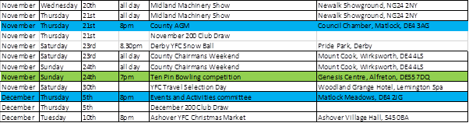

Jane Smith
County Administrator
Derbyshire Federation of Young Farmers’ Clubs
www.derbyshireyfc.org.uk
www.nfyfc.org.uk

Office Hours:
Monday and Thursday 10.30 am – 4.00 pm
Friday 2.00 pm – 4.00 pm
Thursday evening 8.00pm – 10.00 pm

