CHAIRMAN/SECRETARY NEEDS TO READ THIS OUT!
Derbyshire YFC Weekly Update!

The closing date for the sports competition entries is Friday 18th October. Everyone competing must have submitted their membership form to county office by this date! If have any members have access to a set of netball bibs which we could borrow for the competition – please let us know

Staffs YFC Autumn Ball is on Saturday 19th October at Pirelli at Burton Albion. Tickets are on sale via Ticketsource.co.uk. Dress code: Black tie / evening dress. Strictly NO under 18's - current membership cards required plus other ID.

The pre-Rally Beef and Sheep stock judging will be held on Sunday 20th October at Knotlow Farm, Wormhill, SK17 8SL – Please note this venue is different to what was previously advised! by kind permission of the Mosley family starting at 10am, please will members ‘car share’ to limit the number of cars. The carcase judging will be on Wednesday 23rd October at Redferns abattoir, Harpur Hill, Buxton SK17 9HT. The live pig stock judging will be held later in the year. Entries closed on Thursday 10th October and only three clubs have sent entries! The points from these competitions will go forward to the Rally points.

Club officers wishing to access the restricted members’ area on the Derbyshire YFC website the password is ‘Newyear2019’

Minutes of the Executive Committee Meeting are attached. A proposal on a £1.50 increase to the county levy will go forward to the County AGM. Amendments to this proposal may be submitted to county office by Thursday 7th November. If clubs have any other motions they would like to bring to the County AGM they must be made by Thursday 24th October.

An excellent night was had by all who attended the County Dinner and Dance, thanks to the retiring Chairman, Hannah Gregory-Campeau and President, Tim Gratton on their entertaining speeches and the exceptional organisational skills of Emily Topham. Special congratulations to the award winners who are Members Member – Catherine Bunting, Bakewell YFC; Club Officer of the Year: Chairman – Joe Morley, Derby YFC; Secretary – Isobelle Rodgers, Ashover YFC and Treasurer – Charlotte Atkinson, Ashover YFC. The winners of the new Club of the Year trophy are Pleasley YFC.

EweMoo Learning provides training courses for farmers and smallholders on everything from administering medicine, getting started in smallholding and learning how to lamb sheep. The course covers
- Common medicines & how they work
- Understand bacteria
- Antibiotic classes & reducing resistance
- Administering medicines safely & effectively
- Wormers & reducing resistance
- How to safely store & maintain medicines ​
- Safe disposal of sharps & medicines
- Medicine record keeping
Our EweMoo Learning medicine course is typically 2 ½ hours long, with a tea break and a short quiz at the end. Classes are limited to 15 people to enable it to be tailored to the interests of each group. The course content has been approved by Red Tractor and participants are given a certificate for their farm assurance herd health plan.
Typically the course has been priced at £50 per person; subsequent people from the same farm will be charged £35. For YFC members we would charge £35 per person. As a thank you we will reimburse the organisation £5 for every young farmer who attends.
We have a course running in early November 2019 and January 2020 if you are interested, contact: Helen 07972260299 or Emma 07800803029.

Future Dates!
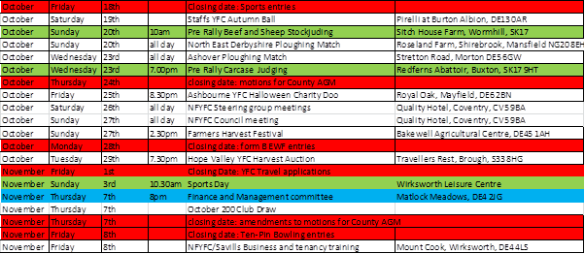

Jane Smith
County Administrator
Derbyshire Federation of Young Farmers’ Clubs
www.derbyshireyfc.org.uk
www.nfyfc.org.uk

Office Hours:
Monday and Thursday 10.30 am – 4.00 pm
Friday 2.00 pm – 4.00 pm
Thursday evening 8.00pm – 10.00 pm

