CHAIRMAN/ SECRETARY NEED TO READ THIS OUT!
Derbyshire YFC Weekly Update!
County AGM – will take place on Thursday 22nd November in the Council Chamber, County Hall, Matlock starting at 8pm. If any club wishes to send forward any Proposals they are required by Thursday 25th October, these will be circulated to clubs and any amendments are required by Thursday 8th November after which the meeting agenda will be circulated.
Bakewell YFC Halloween Party on Friday 26th October at Biggin Village Hall. £5 on the door, Fancy Dress Optional, 16+, ID required - Wrist Band Policy in operation. All 16 and 17 year olds must have a membership card and a parental consent form on the night.
Staffs YFC Spooktacular Ball on Saturday 27th October - Pirelli at Burton Albion. Tickets on sale via Ticketsource.co.uk. Dress code: Black tie / evening dress. Strictly NO under 18's - current membership cards required plus other ID.
Live and Carcase Judging - The Beef and Lamb Judging will be held on Sunday 28th October – 10am at Hazelwood Hall Farm, Belper, DE56 4AW, BKPO the Heath Family.
Harvest Auction – Hope Valley YFC have their annual Harvest Auction on Tuesday 30th October at the Travellers Rest, Brough, S33 8HG starting at 7.30pm. All proceeds to the Children’s Hospital Charities and club funds
County Dinner and Dance Award Winners – The Club Chairman of the Year Award was presented to James Booth, Belper YFC, the Club Secretary of the Year Award was won by Mark Limer, Ashbourne YFC and Alice Wood, Barlow YFC was given the Club Treasurer of the Year Award. The Members Member Award was won by Lucy Etches. Congratulations and a very well done to all!
Executive Committee - Meeting minutes attached
EMA Train the Trainer course is being held on 9th and 10th of February 2019 at the Mount Cook Adventure in Derbyshire. Each County has been reserved 3 spaces and those who complete the course will be able to present the Curve modules, please let Jane know of anyone who would like to be considered for a place
Other Organisations
Ashover Ploughing Match on Wednesday 24th October at Span Carr Farm, Ashover, S45 0LJ
Farmers Harvest Festival on Sunday 28th October 2.30pm at the Agricultural Business Centre, Bakewell YFC Forthcoming Dates !
closing date for YFC Travel 2019 applications Friday 2nd November, trip details can be found on the NFYFC website: http://www.nfyfc.org.uk/travelwithYFC/yfctravel
Finance and Management Committee meeting on Thursday 1st November
Pleasley YFC Bonfire on Friday 2nd November at North Wingfield
Enderby YFC annual Halloween doo on Friday 2nd November
Sports Day on Sunday 4th November –Wirksworth Leisure Centre
Barlow YFC Bonfire on Tuesday 6th November at The Hawthorns, Lydgate, Holmesfield, S18 7WB
Derby YFC Snow Ball Saturday 10th November – The Bentley Brook Inn
Farmers Weekly Ag Careers Live is a free event held on the Thursday 15th November from 10:00 – 15:00 at Villa Park, Birmingham
North West Christmas Ball Friday 14th December Pavilion Gardens, Buxton SK17 6BE
#YFCSki19 – Saturday 5th–Saturday 12th January 2019, Belle Plagne, France
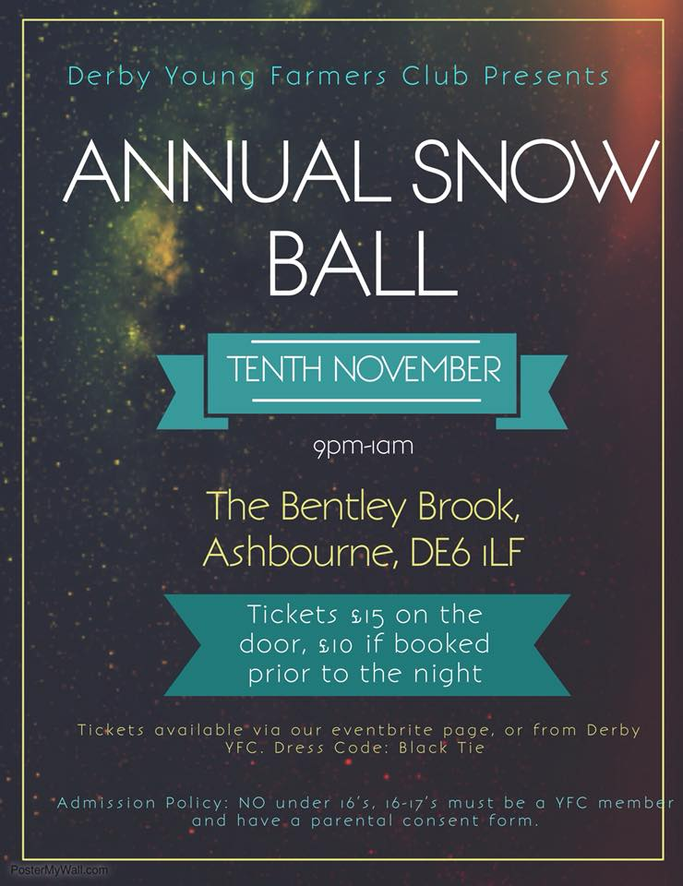
Please note the Derbyshire YFC website is: http://www.derbyshireyfc.org.uk and the NFYFC website is: http://www.nfyfc.org.uk

Jane Smith
County Administrator
Derbyshire Federation of Young Farmers’ Clubs
www.derbyshireyfc.org.uk

Office Hours:
Monday and Thursday 10.30 am – 4.30 pm
Thursday 8.00 pm – 10.00 pm
Friday 2.00 pm – 4.00 pm

